**Assignment 5**

**Question 1**

**Name 5 sorting algorithms, also write their time complexities(best, average, worst).**

|  |
| --- |
|  |
|  | **Best** | **Average** | **Worst** |  |
| [**Selection Sort**](http://geeksquiz.com/selection-sort/) | **Ω(n^2)** | **θ(n^2)** | **O(n^2)** |  |
| [**Bubble Sort**](http://geeksquiz.com/bubble-sort/) | **Ω(n)** | **θ(n^2)** | **O(n^2)** |  |
| [**Insertion Sort**](http://geeksquiz.com/insertion-sort/) | **Ω(n)** | **θ(n^2)** | **O(n^2)** |  |
| [**Heap Sort**](http://geeksquiz.com/heap-sort/) | **Ω(n log(n))** | **θ(n log(n))** | **O(n log(n))** |  |
| [**Quick Sort**](http://geeksquiz.com/quick-sort/) | **Ω(n log(n))** | **θ(n log(n))** | **O(n^2)** |  |

**Question 2**

**Implement selection sort algorithm using Python.**

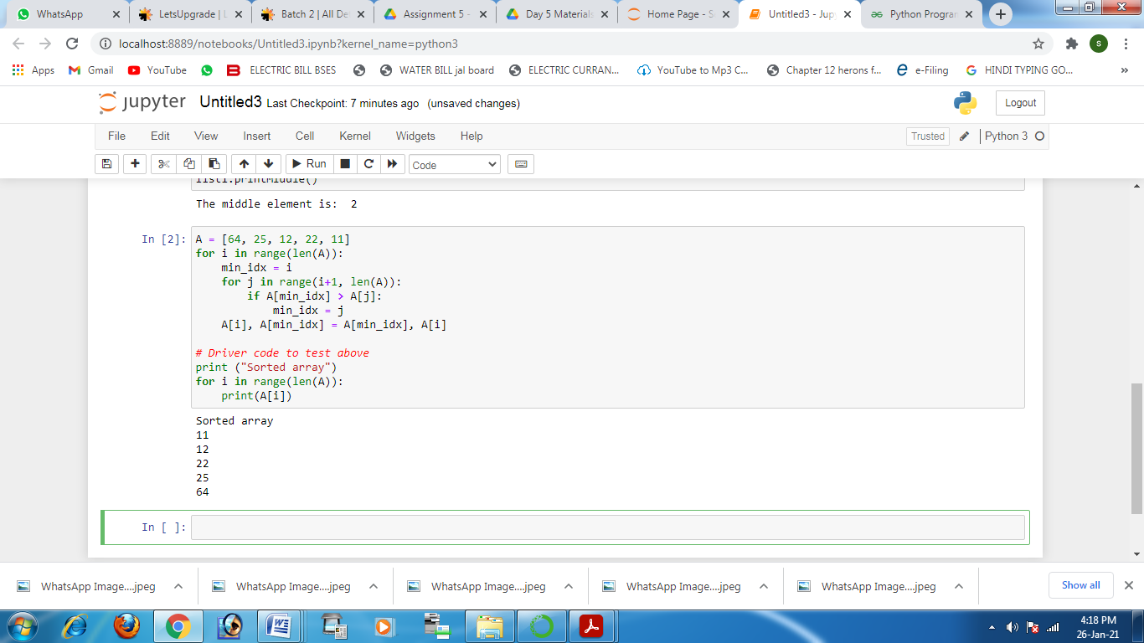

**Question 3**

**Implement pop operation of the stack**

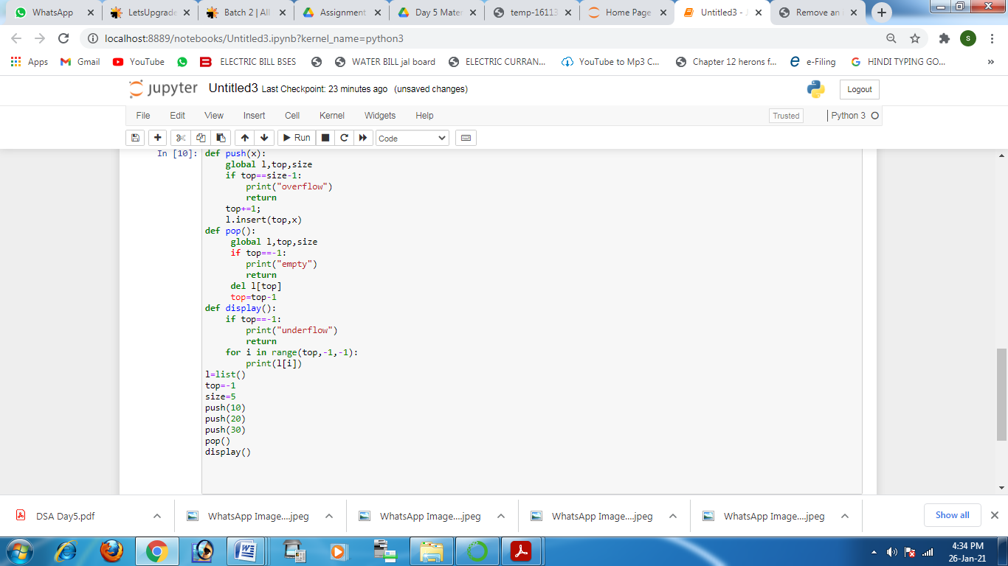

**Question 4**

**Implement dequeue operation of the queue**

